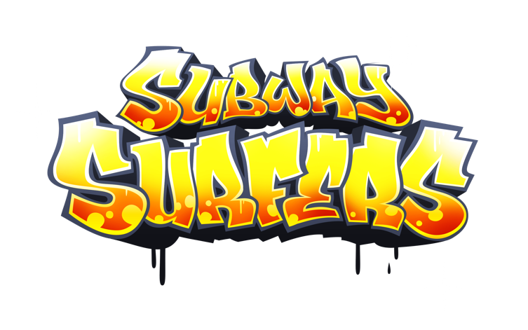

This is an endless runner game developed by Kiloo using Unity. The main goal of this game is trying to escape the capture from the Inspector of the train station running down the tracks. During the game is possible to collect money and find some powerups. My model of this game on Machinations is:

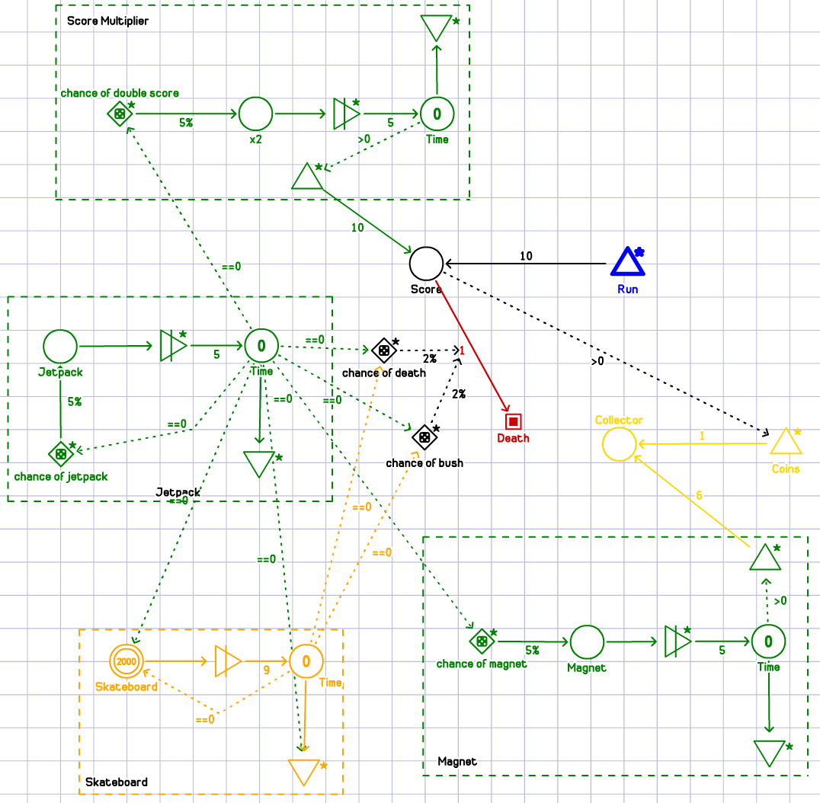

**Game progress model**

During the game you have to complete some missions to obtain a higher multiplier for your score, but it’s not necessary.

**Game economy model**

In the game there two types of collectable resources: coins and keys. Coins are very common during the game and are used to buy new characters, enhance powerups and buy other stuff like skateboards and skateboard skins. Keys are pretty rare and are used mostly to add new powerups to your skateboard, but also used to revive your character whenever you have been caught.

Coins collection is modeled with the yellow part as an infinite resource that pull one resource at a time in a circle collector component.

**Game level design**

This game has no levels, but, as aforementioned, you can improve your score multiplier completing some quests. For each single multiplier score (from 1 to 30) you have to complete 3 quests, few examples are “Collect exactly 500 coins in one run” or “Pick up 5 Magnet in one run” and so on. When you reach 30 you can still continue to complete quests, but you can’t increase your multiplier. From now on every 3 quests completed you receive a Mystery Box.

**Game randomization model**

In this game there are two random things, the first is when and where powerups appear on the map and the second is the content of the Mystery Box.

From my personal experience I can say that when you have to find a specific powerup to complete your mission, it appears rarely. Moreover, if your next mission (unseen) is for example “Pick up 3 Score Multiplier” they will appear very often and then when the mission is active they disappear.

This randomization part is modeled inside the green squares, here an example. In the case of the magnet there is a gate component modeled as a dice that activate a converter stage with a 5% of chance. After that a timer will start ticking and till the end of the time the coin collector component receives more coins. The timer is modeled as a resource drained each second by a drain component, but while the timer is greater than 0 it generates coins. All the others powerups are modeled in the same way.

**New Game**

The new feature implemented is a bonus map unlockable collecting the map pieces. Every time the user collects 4 piece of a map the game teleport him in a new map for a limited amount of time where he can’t lose the game. In this mode he can find only 2 kinds of powerups; the coin magnet and the score multiplier. Moreover, if he is lucky he could find either a new skin for his character, that could be a skin for the avatar or a skin for the skateboard, or a new character of the game. After the timeout he will be moved back to the original game.

The chance for collecting a piece of the map is set to 5% and modeled like the others powerups. The collector of the pieces is modeled as a pool component that wait 4 resources before trigger the converter. The time is modeled like in the other cases aforementioned. The chance of collect a new skin or a new character is modeled in the same way as a powerups generator but with a change of 3% and there is a pool component to collect the reward.

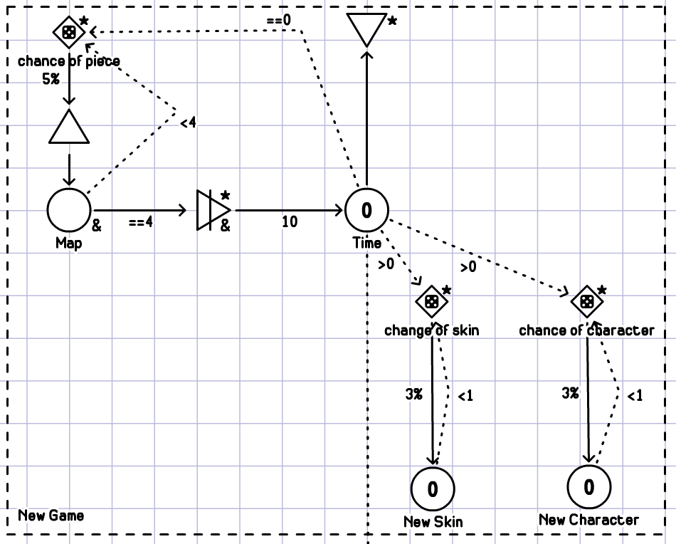

**Complete game**

